# 103121727_105229874585070_6385175772093551380_n (1).png

# CLEANSOCIETY

A PROJECT REPORT

*Submitted by*

**PATEL DHRUV VISHNUBHAI (2023095900004485)**

**PATEL AYUSH RAJESHKUMAR (2023095900004493)**

**PATEL SHIVAM NILESHBHAI (2023095900004504)**

**PATEL KRISH VINODBHAI (2022095900023543)**

**MODI HARSH MITESHKUMAR (2022095900026456)**

***In fulfilment of the subject Mini Project - II of***

**B.E. Semester VI**

***In***

### Department of Computer Engineering

**Sankalchand Patel College of Engineering, Visnagar**

**Sankalchand Patel University, Visnagar**

**April 2025**

 

**Sankalchand Patel College of Engineering, Visnagar**

At & Post: Visnagar, Gujarat - 384315

# CERTIFICATE

###### This is to certify that the project entitled **CLEANSOCIETY** has been carried out by **Dhruv V. Patel (2023095900004485)** under my guidance in fulfilment of the subject Mini Project –II of Bachelor Of Engineering in Computer engineering (Semester VI) of Sankalchand Patel University, Visnagar during the academic year 2024- 25

**Internal Guide: Name: Ekta V. Patel**

###### **Date: 29/03/2025**

Dr. Kirit J. Modi

Head of the Department

 

**Sankalchand Patel College of Engineering, Visnagar**

At & Post: Visnagar, Gujarat - 384315

# CERTIFICATE

###### This is to certify that the project entitled **CLEANSOCIETY** has been carried out by **Ayush R. Patel (2023095900004493)** under my guidance in fulfilment of the subject Mini Project –II of Bachelor Of Engineering in Computer engineering (Semester VI) of Sankalchand Patel University, Visnagar during the academic year 2024- 25

**Internal Guide: Name: Ekta V. Patel**

###### **Date: 29/03/2025**

Dr. Kirit J. Modi

Head of the Department

 

**Sankalchand Patel College of Engineering, Visnagar**

At & Post: Visnagar, Gujarat - 384315

# CERTIFICATE

###### This is to certify that the project entitled **CLEANSOCIETY** has been carried out by **Shivam N. Patel (2023095900004504)** under my guidance in fulfilment of the subject Mini Project –II of Bachelor Of Engineering in Computer engineering (Semester VI) of Sankalchand Patel University, Visnagar during the academic year 2024- 25

**Internal Guide: Name: Ekta V. Patel**

###### **Date: 29/03/2025**

Dr. Kirit J. Modi

Head of the Department

 

**Sankalchand Patel College of Engineering, Visnagar**

At & Post: Visnagar, Gujarat - 384315

# CERTIFICATE

###### This is to certify that the project entitled **CLEANSOCIETY** has been carried out by **Krish V. Patel (2022095900023543)** under my guidance in fulfilment of the subject Mini Project –II of Bachelor Of Engineering in Computer engineering (Semester VI) of Sankalchand Patel University, Visnagar during the academic year 2024- 25

**Internal Guide: Name: Ekta V. Patel**

###### **Date: 29/03/2025**

Dr. Kirit J. Modi

Head of the Department

 

**Sankalchand Patel College of Engineering, Visnagar**

At & Post: Visnagar, Gujarat - 384315

# CERTIFICATE

###### This is to certify that the project entitled **CLEANSOCIETY** has been carried out by **Harsh M. Modi (2022095900026456)** under my guidance in fulfilment of the subject Mini Project –II of Bachelor Of Engineering in Computer engineering (Semester VI) of Sankalchand Patel University, Visnagar during the academic year 2024- 25

**Internal Guide: Name: Ekta V. Patel**

###### **Date: 29/03/2025**

Dr. Kirit J. Modi

Head of the Department

Table of Contents

[Acknowledgement](#_TOC_250013) 08

[Abstract](#_TOC_250012) 09

1. [Introduction](#_TOC_250011) 10
   1. [Overview of project](#_TOC_250010) 11
   2. Object & scope of project 11
   3. [Project Profile](#_TOC_250009) 13
2. Technology 14
   1. Software requirement 14
   2. Hardware requirement 14
3. Data Modeling Diagram 15
   1. Data Flow Diagram 15
   2. [Use Case Diagram 1](#_TOC_250004)7
   3. Sequence Diagram 18
   4. Activity Diagram 19
   5. E-R Diagram 20
4. [Data Dictionary](#_TOC_250001) 21
5. Snapshots 24
6. [Conclusion](#_TOC_250000) 29
7. Refrences30

# ACKNOWLEDGMENT

### Acknowledgement

This project report on **CLEANSOCIETY** beats the important of several person with the proper guidance of those persons, this project has been completed.

We extend our sincere and heartful thanks to our esteemed guide **Ekta V. Patel** for providing me and my team an opportunity for us to show our hidden talent to you & providing their suggestion for betterment of our program our project would not have been possible without your faith on us.

We would like to extend thanks to our respected Head of the Department, **Dr. Kirit J. Modi** for allowing us to use the facilities available.

Thank You & Regards,

Dhruv V. Patel

Ayush R. Patel

Shivam N. Patel

Krish V. Patel

Harsh M. Modi

# ABSTRACT

* Clean Society is an innovative web-based platform designed to address the growing challenge of urban waste management by enabling citizens to report garbage accumulation in public spaces. The platform allows users to file complaints by uploading images of unclean areas, providing the exact location, and submitting relevant details. These complaints are then forwarded to the respective municipal corporation, which responds with an estimated cleanup timeline.
* The system features a user-friendly interface with functionalities such as user authentication (login/logout), complaint tracking, and status updates to ensure transparency. Users can monitor the progress of their complaints, receive notifications about actions taken, and provide feedback on the resolution process. The platform also maintains a complaint history, allowing users to review past reports and track municipal performance over time.
* Clean Society aims to bridge the gap between citizens and municipal authorities, fostering greater accountability and efficiency in waste management. By leveraging technology, it encourages community participation in environmental cleanliness, promotes civic responsibility, and contributes to a healthier, more sustainable urban ecosystem.

**Chapter-1**

### INTRODUCTION

Waste management is a critical challenge in urban areas, with garbage accumulation in public spaces leading to environmental pollution, health hazards, and decreased quality of life. Despite municipal efforts, inefficient reporting systems and delayed responses often result in unattended waste, negatively impacting communities. Citizens frequently struggle to find an effective way to report unclean areas, and municipal authorities lack a streamlined process to track and address complaints efficiently. There is a pressing need for a structured, technology-driven solution that enables real-time communication between citizens and municipal bodies to ensure timely waste disposal and cleaner surroundings.

Clean Society is a web-based platform designed to bridge this gap by empowering users to report garbage accumulation directly to municipal authorities. Through a simple interface, users can upload images, provide location details, and describe waste-related issues, allowing authorities to assess and respond accordingly. The platform enables complaint tracking, status updates, and estimated cleanup timelines, ensuring transparency and accountability. Additionally, municipal corporations can manage and prioritize complaints using a dedicated dashboard, streamlining their workflow for faster resolution. By leveraging technology, Clean Society enhances public participation in waste management and strengthens municipal efficiency.

The platform integrates modern technologies such as React.js or Vue.js for the frontend, Node.js or Django for backend operations, and Google Maps API for accurate geolocation tracking. With secure authentication, users can log in to track complaints, view complaint histories, and provide feedback on municipal responses. Clean Society not only simplifies the complaint process but also fosters civic responsibility by encouraging active community engagement in maintaining cleanliness. By creating a direct communication channel between the public and municipal bodies, the platform contributes to a more sustainable, hygienic, and organized urban environment.

###### **OVERVIEW OF PROJECT**

Clean Society is a web-based platform designed to streamline urban waste management by enabling citizens to report garbage accumulation in public areas. Users can submit complaints by uploading images, specifying locations, and providing descriptions, ensuring that municipal authorities receive precise and actionable reports.

Each complaint is tracked through a structured system where users can monitor progress, receive real-time updates, and get estimated cleanup timelines. The platform also features user authentication, complaint history, and a feedback system to enhance transparency and accountability in municipal waste management.

To optimize efficiency, Clean Society provides a dedicated dashboard for municipal corporations, allowing them to categorize, assign, and resolve complaints effectively. The platform integrates modern technologies, including HTML, CSS and Jscript for the frontend, JQuery and PHP for the backend, and Google Maps API for geolocation-based reporting. By fostering direct communication between citizens and authorities, Clean Society promotes civic engagement, encourages responsible waste disposal, and contributes to cleaner, healthier urban environments.

###### **OBJECTIVE & SCOPE OF PROJECT**

**1.2.1 Objectives**

The primary objectives of **Clean Society** are to enhance urban cleanliness, improve waste management efficiency, and promote civic engagement. The platform aims to:

1. **Simplify the Complaint Process** – Provide an intuitive interface for users to easily report garbage-related issues by uploading images, specifying locations, and adding descriptions.
2. **Enhance Transparency and Accountability** – Allow users to track their complaints in real time, receive updates on municipal actions, and ensure authorities are held accountable for timely waste management.
3. **Improve Municipal Response Efficiency** – Offer a structured system for municipal corporations to categorize, assign, and resolve complaints, optimizing resource allocation for waste management.
4. **Promote Sustainable Waste Management Practices** – Raise awareness about responsible waste disposal and encourage cleaner habits within communities.
5. **Leverage Technology for Better Service Delivery** – Utilize modern web technologies such as Google Maps API for location-based reporting, real-time status updates, and data analytics to enhance waste management strategies.

**1.2.2 Scope**

The **scope** of Clean Society extends to multiple stakeholders, including citizens, municipal authorities, and urban planners, ensuring a comprehensive approach to waste management.

* **User Management & Authentication** – Users can register, log in securely, manage their profiles, and track their complaints. Authentication ensures that complaints are legitimate and prevents spam reports.
* **Complaint Reporting System** – Users can submit complaints with images, location details, and descriptions. Each complaint is assigned a unique reference number for tracking.
* **Complaint Tracking & Notifications** – Users receive real-time updates on complaint status, including submission confirmation, processing, and resolution. Notifications ensure users are informed at every stage.
* **Municipal Corporation Dashboard** – A dedicated dashboard allows authorities to view, filter, prioritize, and resolve complaints efficiently. Task assignment and progress tracking streamline the response process.
* **Feedback & Rating System** – Users can provide feedback on municipal responses, rate the efficiency of cleanup efforts, and suggest improvements.
* **Data Analytics & Reporting** – Municipal authorities can analyze complaint trends, identify high-risk areas, and improve waste management strategies based on real-time data.
* **Scalability & Future Expansion** – The system can be expanded to include additional waste management services such as recycling programs, hazardous waste disposal, and integration with smart city initiatives

###### **1.3 PROJECT PROFILE**

Project Name: CleanSociety

Submitted To: Sankalchand Patel University, Visnagar Front End: HTML5, CSS3,Javascript, JQuery, AJAX

Back End: Php, MySQL Documentation Tool: Microsoft Word Project Guide: Ekta V. Patel

Team Members: Dhruv V. Patel (2023095900004485)

Ayush R. Patel (2023095900004493)

Shivam N. Patel (2023095900004504)

Krish V. Patel (2022095900023543)

Harsh M. Modi (2022095900026456)

**Chapter-2**

### TECHNOLOGY

##### 

##### **2.1 Software Requirements**:

* + Front End: HTML5, CSS3,Javascript, JQuery, AJAX
  + Back End: Php, MySQL
  + Operating System: Windows 7 or higher
  + Technology Used: Android 5.0 (Lollipop) or higher
  + IDE: VS Code

##### **2.2 Hardware Requirements:**

* + Processor: 1GHz
  + Hard disk: 500 MB or higher.
  + RAM: 4 GB or higher

**Chapter-3**

### DATA MODELING DIAGRAM

###### **DATA FLOW DIAGRAM: -**

**3.1.1 Context Level DFD**

**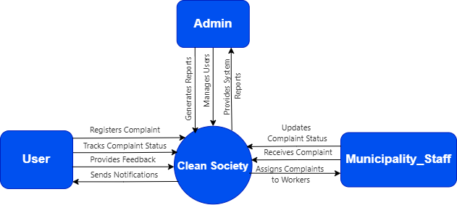**

**3.1.2 1st Level DFD**

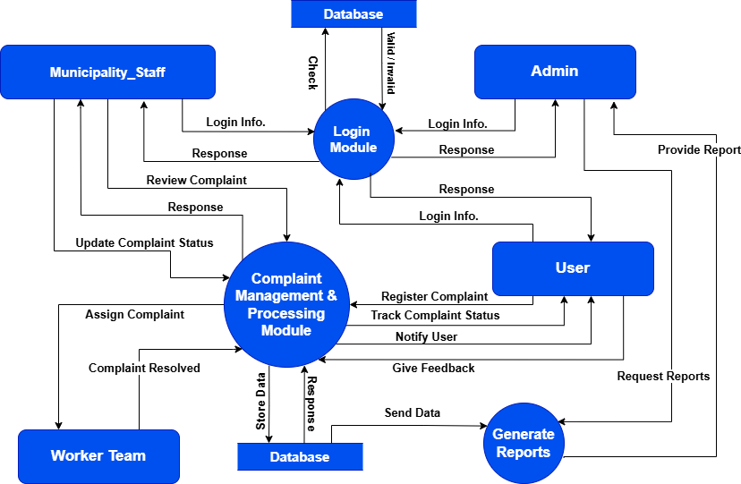

###### USE CASE DIAGRAM: -

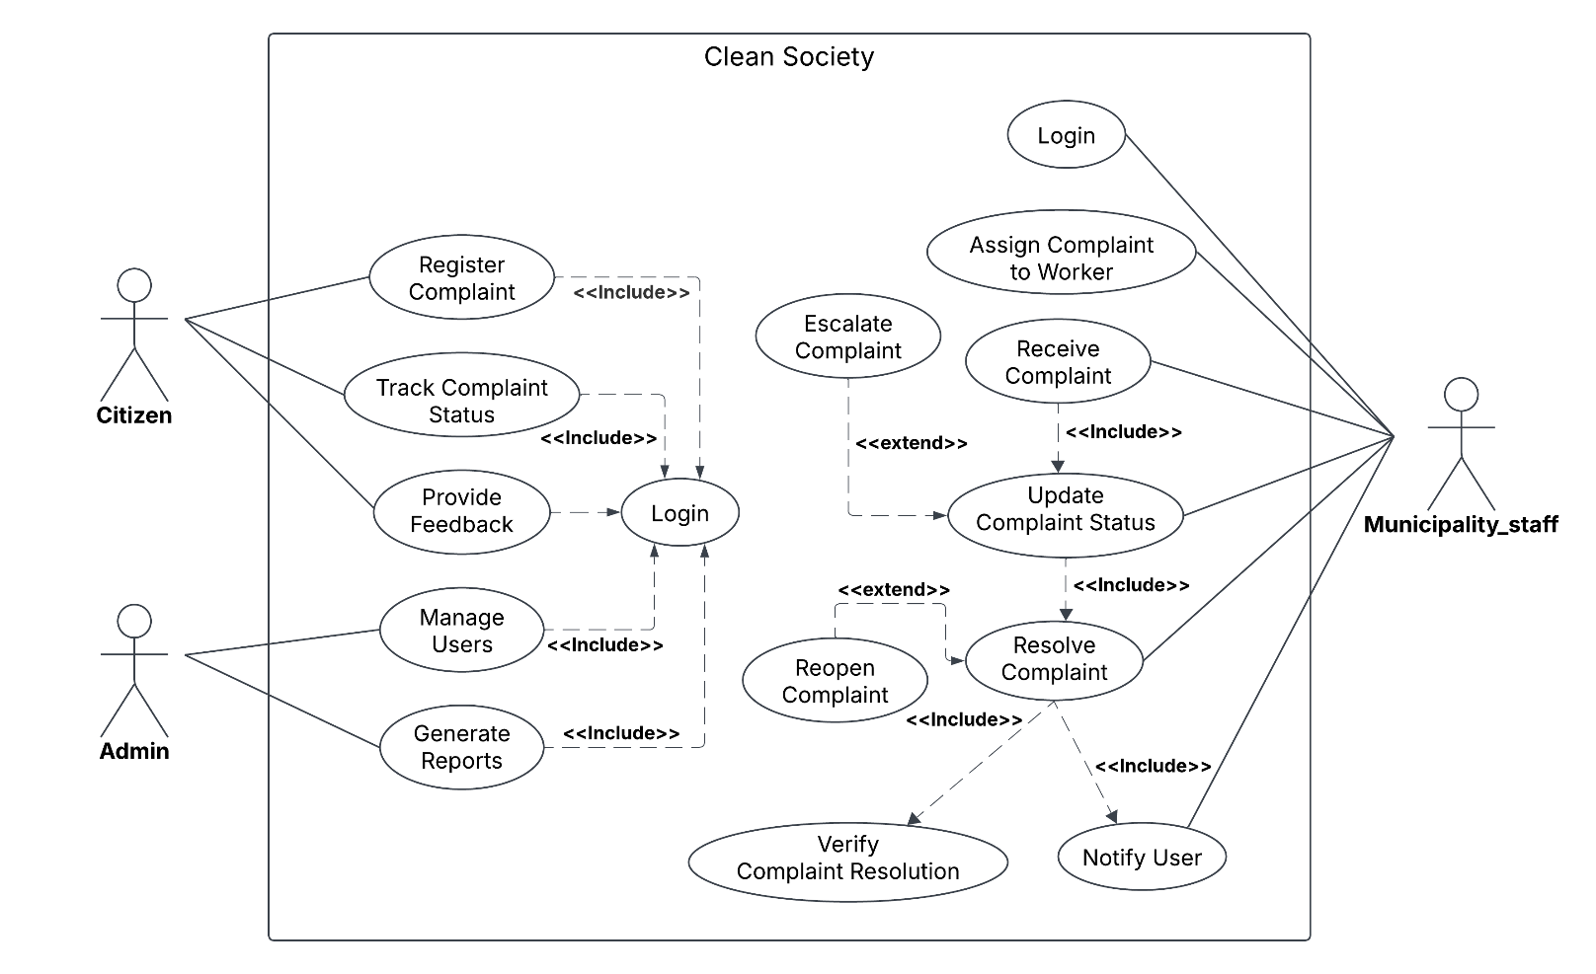

###### SEQUENCE DIAGRAM: -

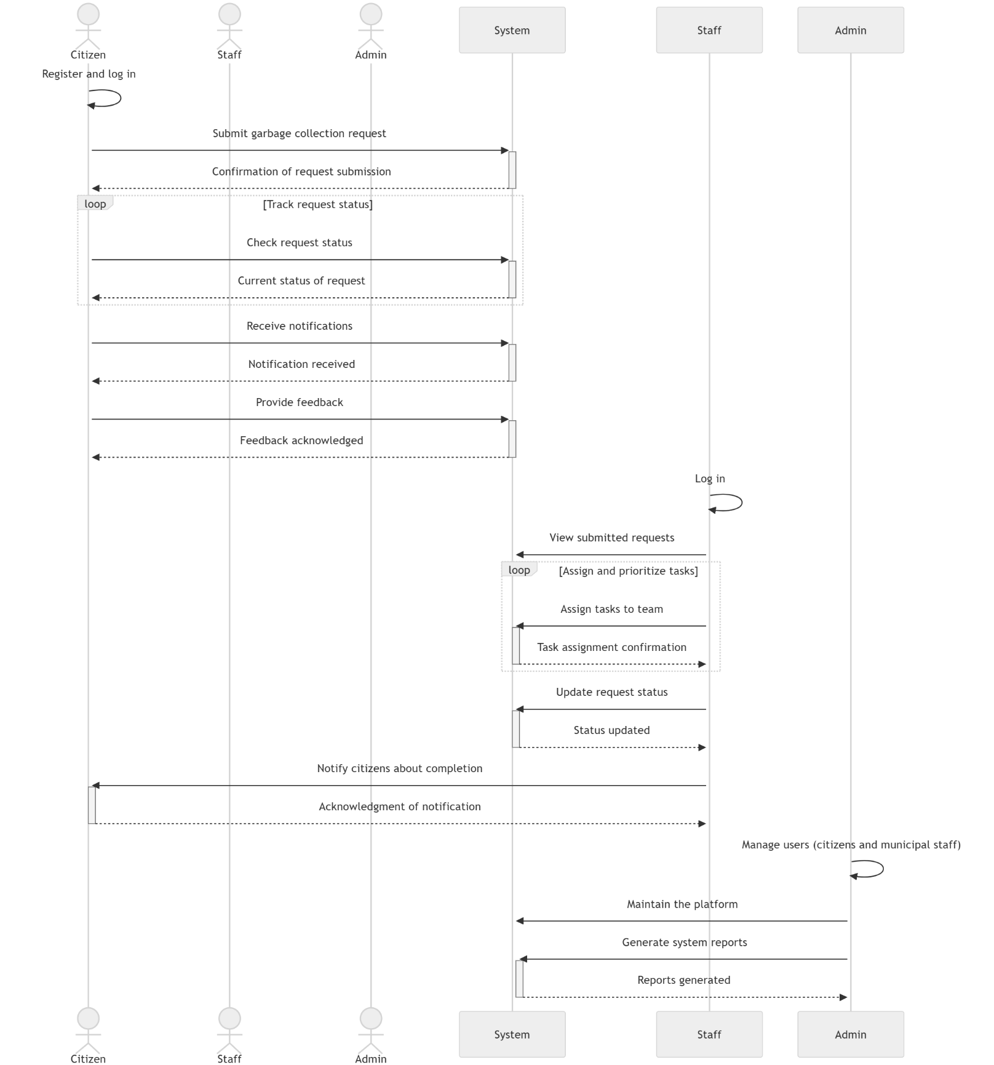

###### ACTIVITY DIAGRAM: -

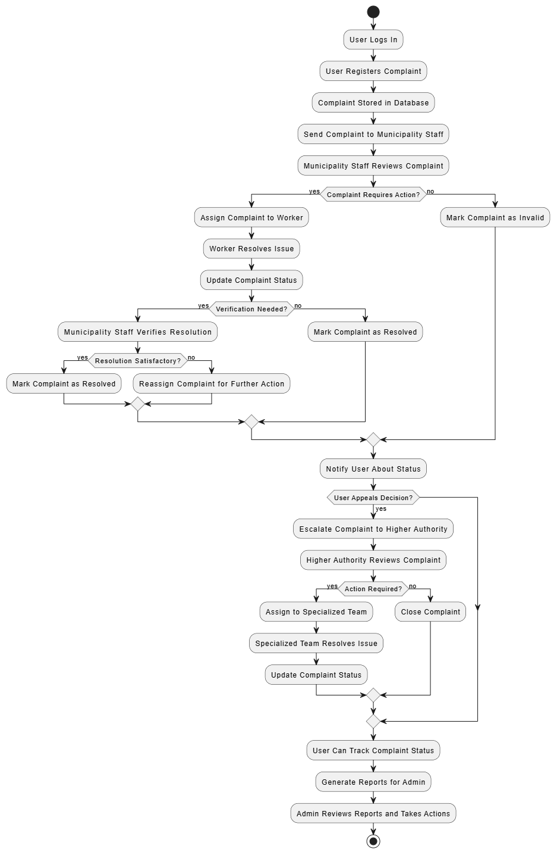

###### E-R DIAGRAM: -

**Clean Society E-R Diagram**

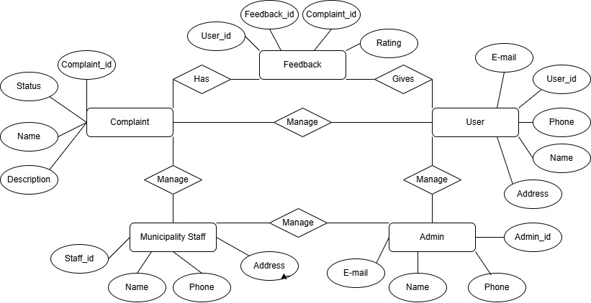

-

**Chapter-4**

### DATA DICTIONARY

**4.1 User Table**

Stores details of users who interact with the system.

|  |  |  |  |
| --- | --- | --- | --- |
| **Field Name** | **Data Type** | **Description** | **Constraints** |
| user\_id | INT (PK) | Unique identifier for the user | Primary Key, Auto Increment |
| name | VARCHAR(255) | Full name of the user | Not Null |
| email | VARCHAR(255) | Email address of the user | Unique, Not Null |
| password | VARCHAR(255) | Encrypted password | Not Null |
| phone\_number | VARCHAR(15) | Contact number | Not Null |
| address | TEXT | Residential address | Not Null |
| created\_at | TIMESTAMP | Account creation timestamp | Default: CURRENT\_TIMESTAMP |

**4.2 Complaint** **Table**

Stores complaints registered by users.

|  |  |  |  |
| --- | --- | --- | --- |
| **Field Name** | **Data Type** | **Description** | **Constraints** |
| complaint\_id | INT (PK) | Unique identifier for the complaint | Primary Key, Auto Increment |
| user\_id | INT (FK) | User who registered the complaint | Foreign Key (User Table) |
| user\_name | VARCHAR (FK) | User who registered the complaint | Foreign Key (User Table) |
| Waste\_Type | VARCHAR(100) | Type of complaint (Solid, Bio, Mix, etc.) | Not Null |
| description | TEXT | Detailed description of the complaint | Not Null |
| status | ENUM('Pending', 'In Progress', 'Resolved', 'Rejected') | Current status of complaint | Default: 'Pending' |
| assigned\_to | INT (FK) | Municipality staff assigned | Foreign Key (User Table) |
| created\_at | TIMESTAMP | Complaint registration timestamp | Default: CURRENT\_TIMESTAMP |

* 1. **Feedback** **Table**

Stores feedback provided by users regarding complaint resolution.

|  |  |  |  |
| --- | --- | --- | --- |
| **Field Name** | **Data Type** | **Description** | **Constraints** |
| feedback\_id | INT (PK) | Unique identifier for feedback | Primary Key, Auto Increment |
| user\_id | INT (FK) | User providing feedback | Foreign Key (User Table) |
| complaint\_id | INT (FK) | Complaint associated with feedback | Foreign Key (Complaint Table) |
| rating | INT | Rating provided (1-5) | Not Null, Check (rating between 1-5) |
| comments | TEXT | Additional comments | Nullable |
| created\_at | TIMESTAMP | Timestamp of feedback submission | Default: CURRENT\_TIMESTAMP |

**4.4 Municipality Staff Table**

Stores details of municipal staff responsible for complaint resolution.

|  |  |  |  |
| --- | --- | --- | --- |
| **Field Name** | **Data Type** | **Description** | **Constraints** |
| staff\_id | INT (PK) | Unique identifier for the staff | Primary Key, Auto Increment |
| name | VARCHAR(255) | Full name of the staff | Not Null |
| email | VARCHAR(255) | Email address of the staff | Unique, Not Null |
| phone\_number | VARCHAR(15) | Contact number | Not Null |
| address | TEXT | Residential address | Not Null |
| created\_at | TIMESTAMP | Timestamp of staff registration | Default: CURRENT\_TIMESTAMP |

**Chapter-5**

**SNAPSHOT**

**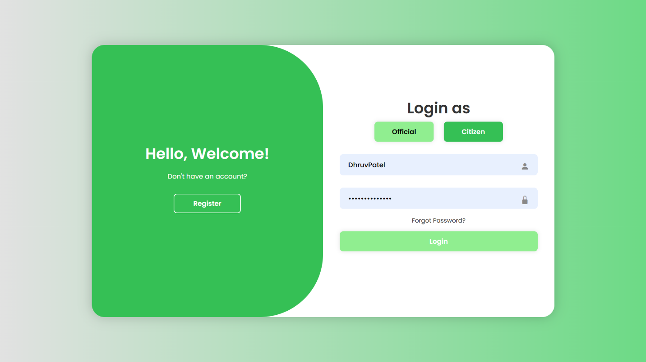5.1 User Login page**

**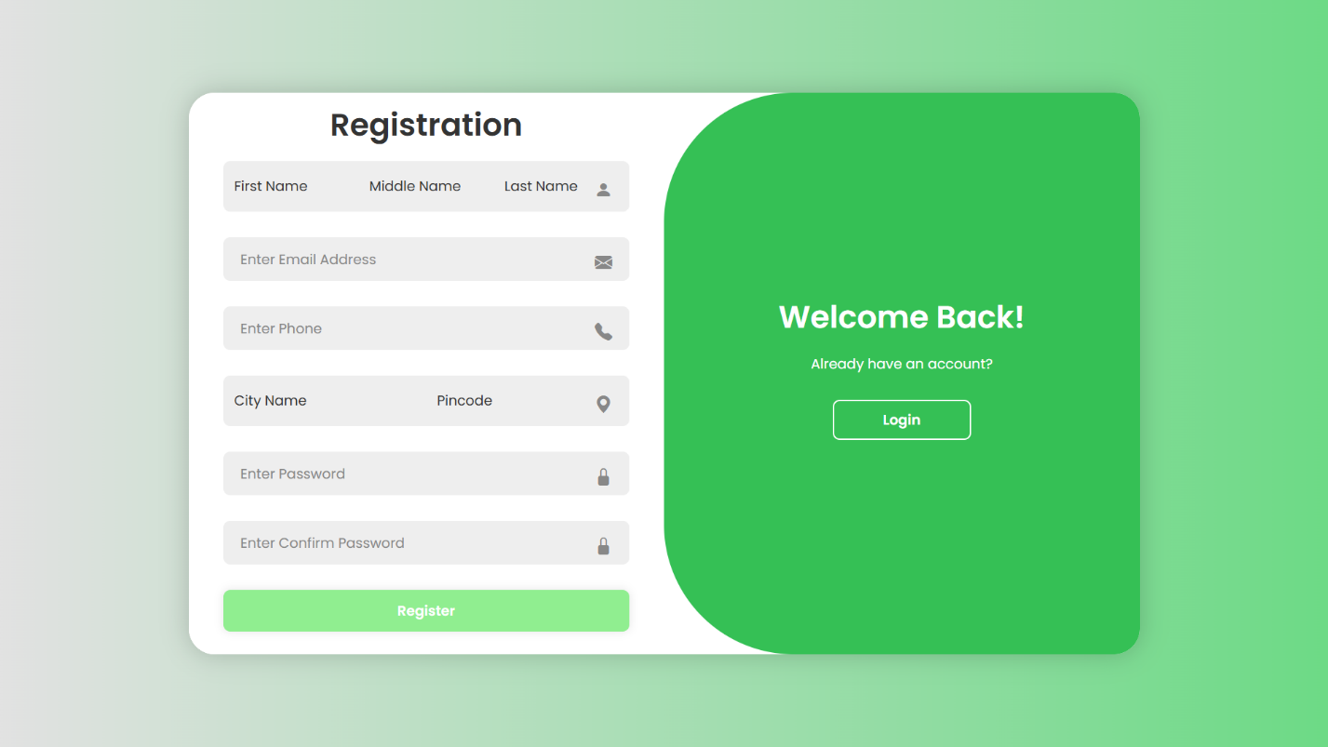5.2 User Registration page**

**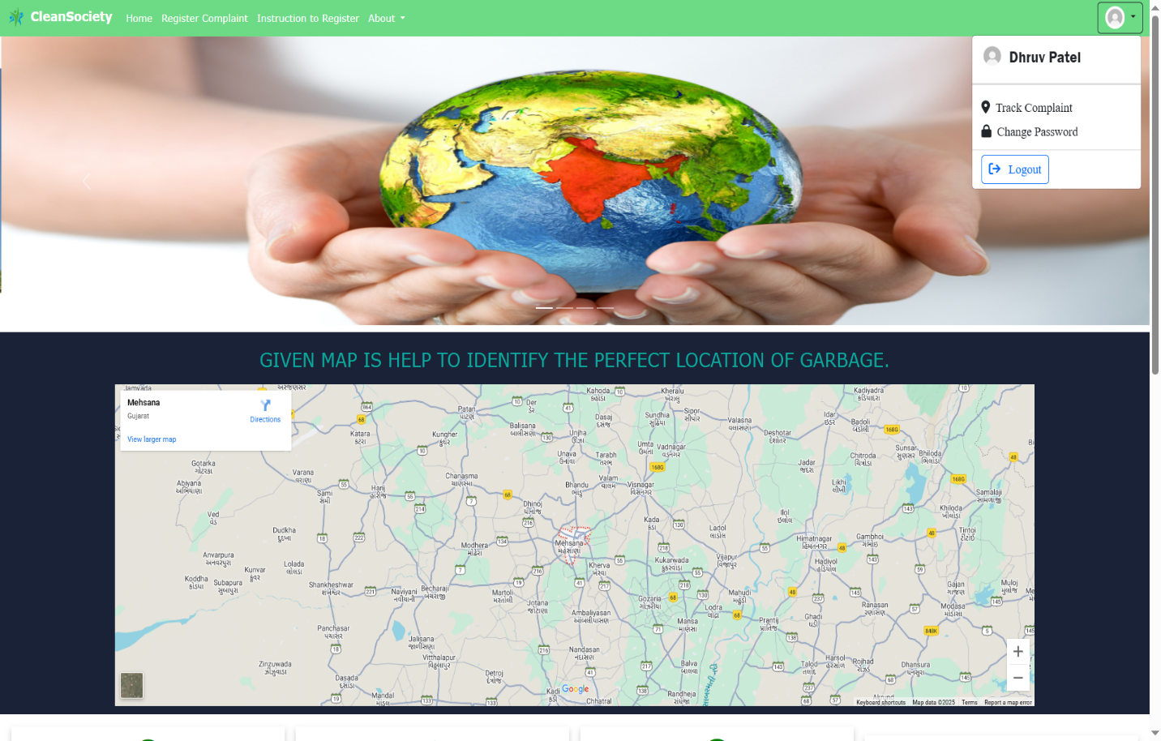5.3 User Home page**

**5.4 User Complaint Register page**

**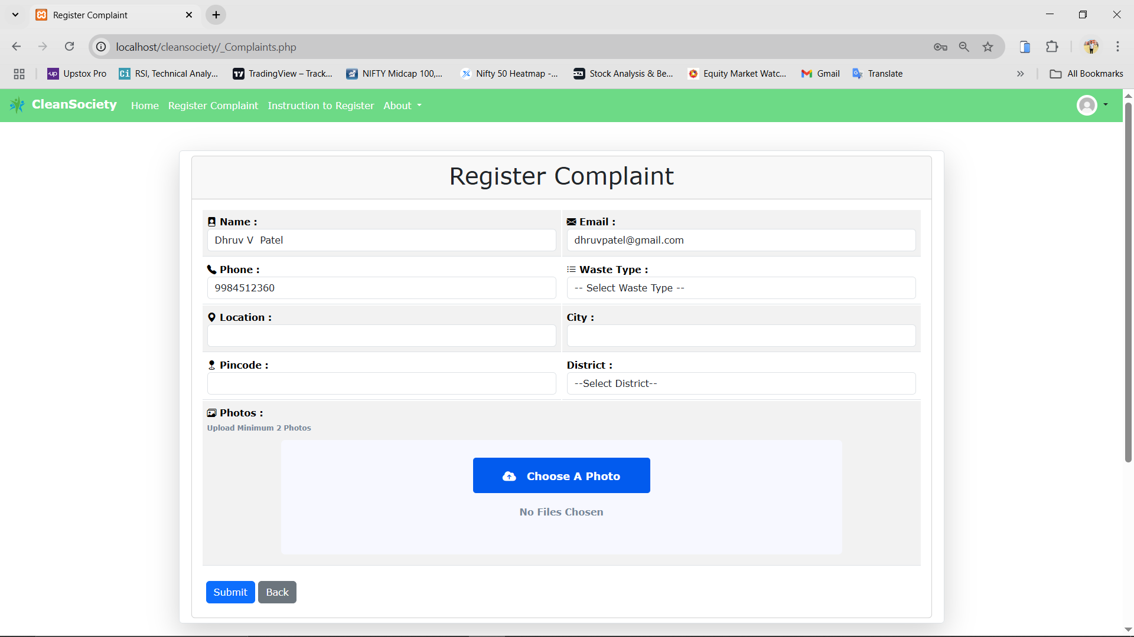**

**5.5 Instruction to Register page**

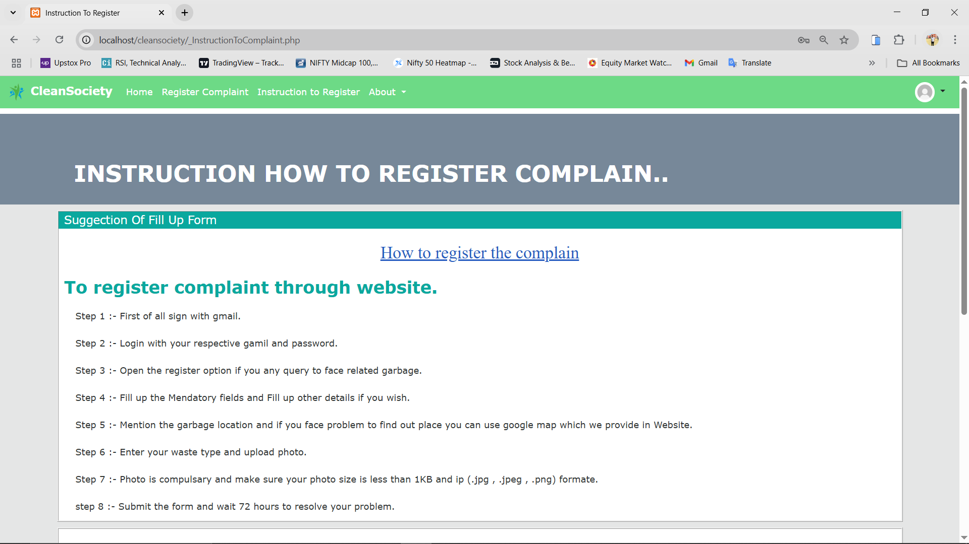

**5.6 Contact US page**

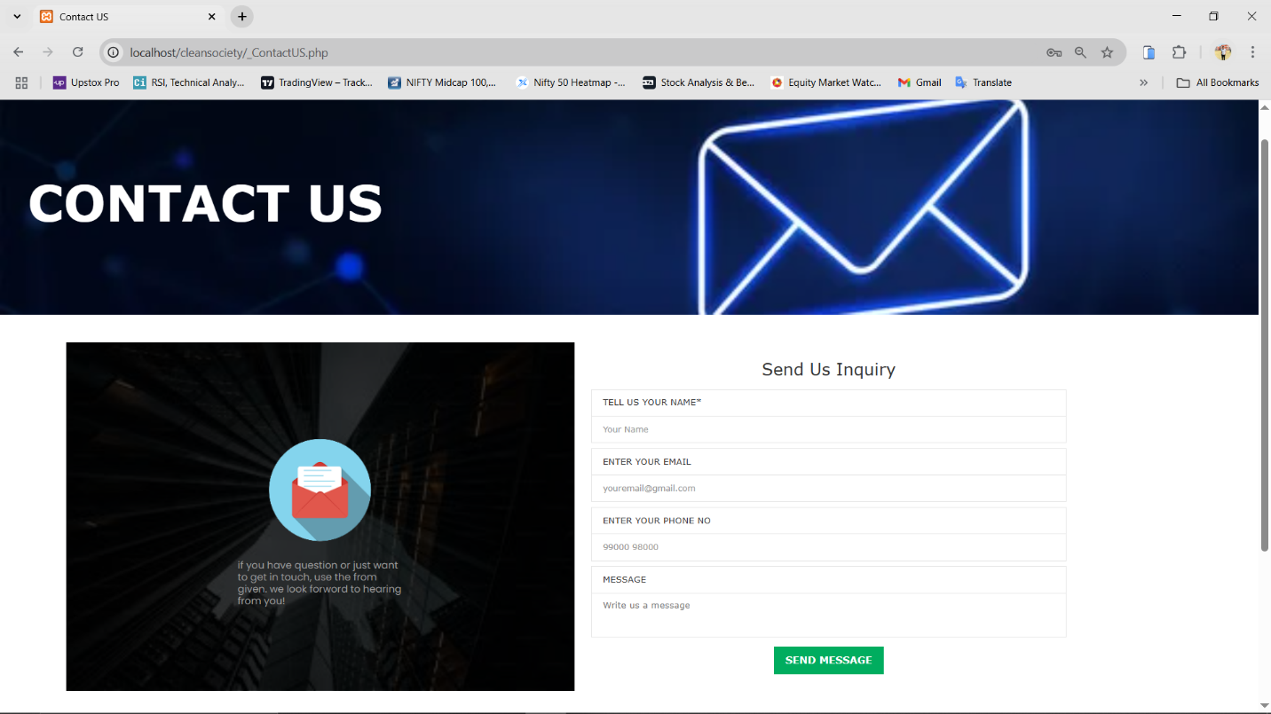

**5.7 Track Complaint Status page**

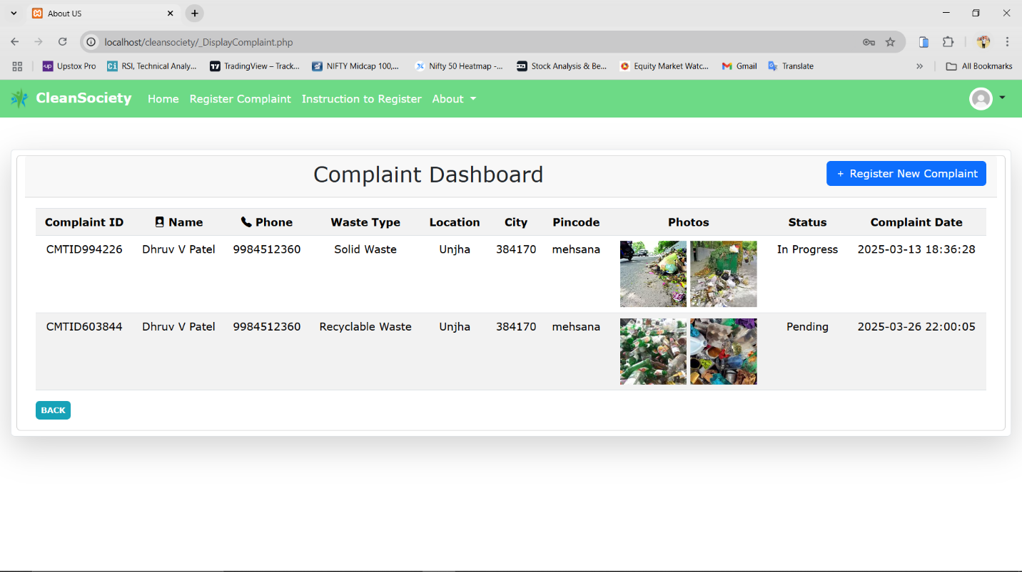

**5.8 Officials Dashboard page**

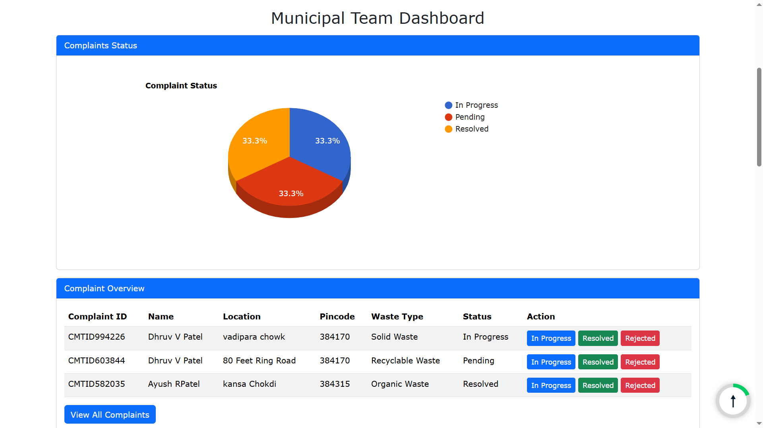

**5.9 Manage Complaints page**

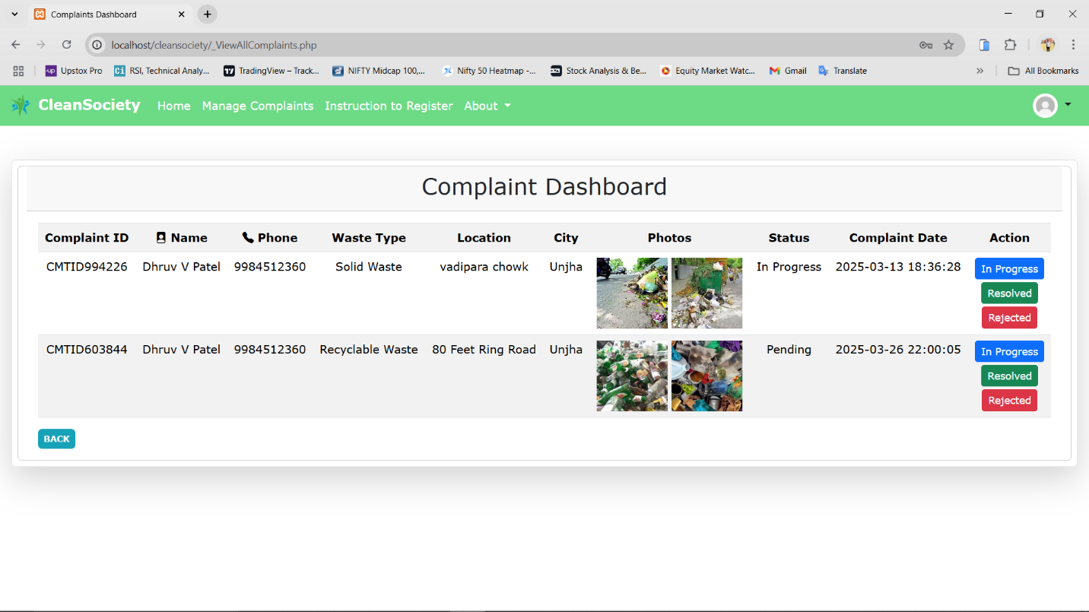

**5.10 Manage Users page**

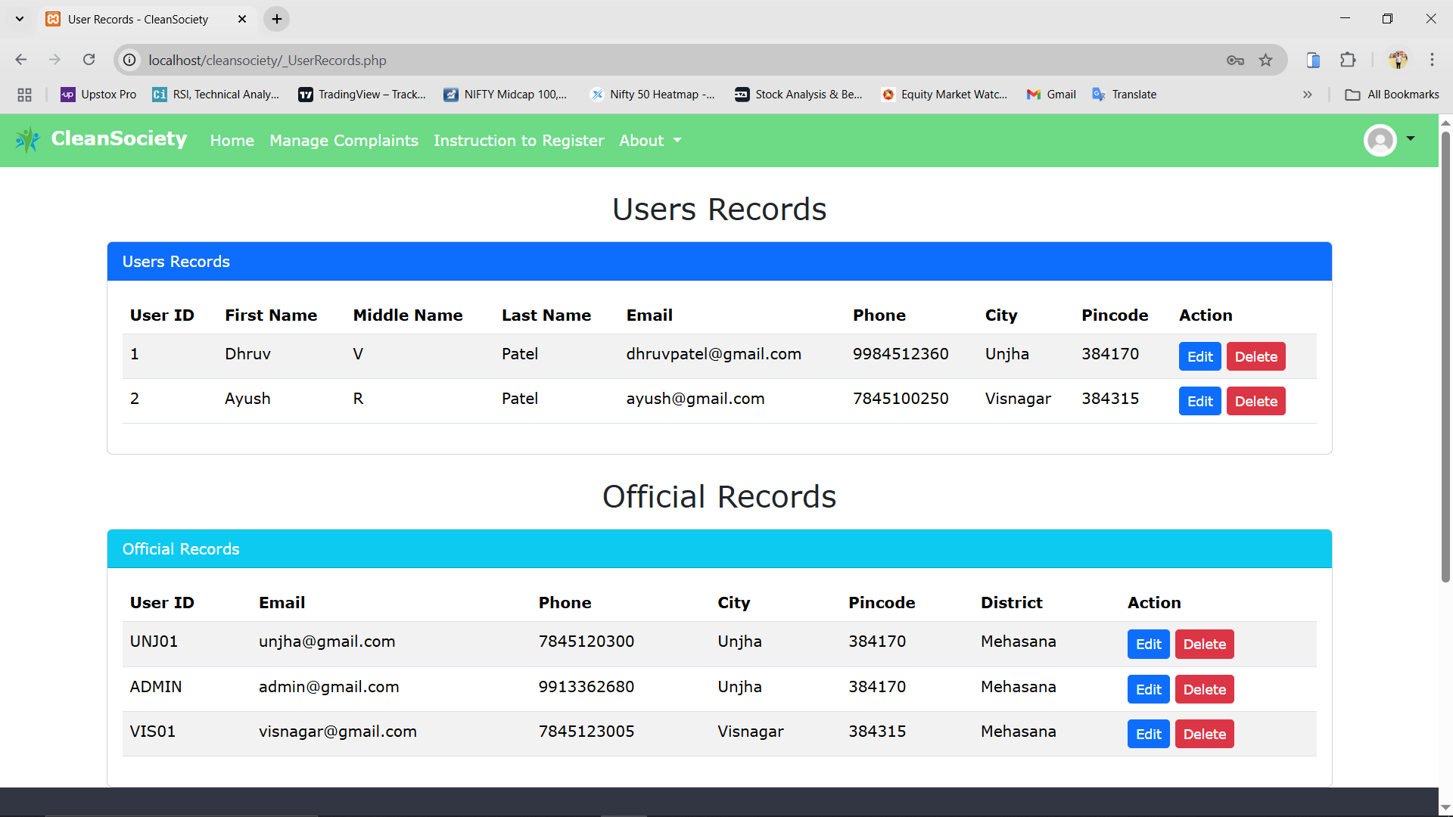

**Chapter-6**

### Conclusion

The **CleanSociety** project aims to bridge the gap between citizens and municipal authorities by providing an efficient and transparent platform for reporting and resolving garbage collection issues. By leveraging technology, the system ensures that complaints are registered, tracked, and addressed in a timely manner, leading to cleaner surroundings and improved public health.

With its user-friendly interface and real-time complaint tracking, **CleanSociety** empowers citizens to take an active role in maintaining a clean environment. Additionally, it enhances the efficiency of municipal waste management by streamlining the complaint resolution process.

Going forward, integrating features like automated reminders, complaint analytics, and AI-driven route optimization for waste collection can further enhance the platform’s effectiveness. By continuously evolving, **CleanSociety** has the potential to make cities cleaner and more sustainable for future generations.

**Chapter-7**

### References

* 1. <https://github.com>
  2. [www.developer.android.com](http://www.developer.android.com/)
  3. <https://developers.google.com/maps/documentation>
  4. <https://swachhbharatmission.gov.in>
  5. <https://www.open311.org>